Autophagy signaling in overload-induced skeletal muscle hypertrophy: a comparison between control and type 1 diabetic rats - SUPPLEMENTAL MATERIAL S3 (presented in Figure 6).

Figure S3.1. Curves used to determine efficiency of the reaction from 18S (A), GAPDH (B), HTPR1 (C) and P62 (D) genes. There was used a sample pool to perform the curves. The reaction showed a good efficiency, which is considered when the R of the curve is closer to 1 and the efficiency between 90 and 110%.

**B**

**A**

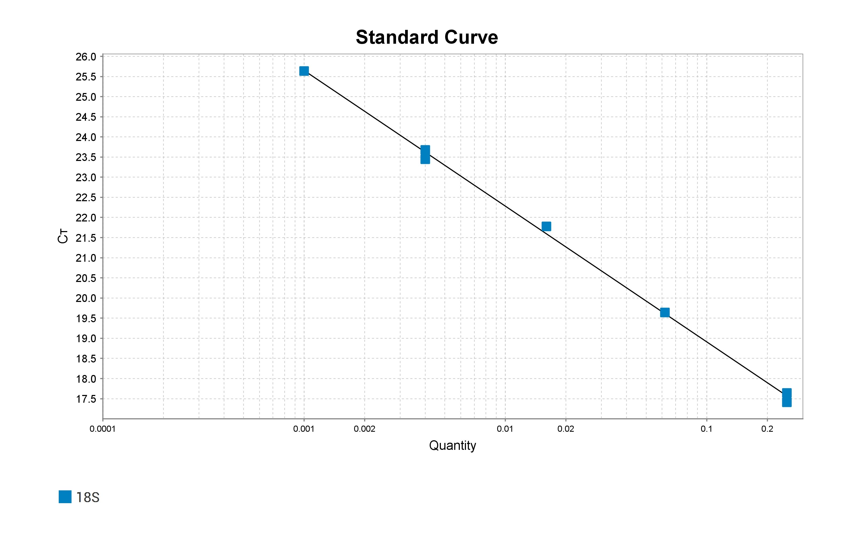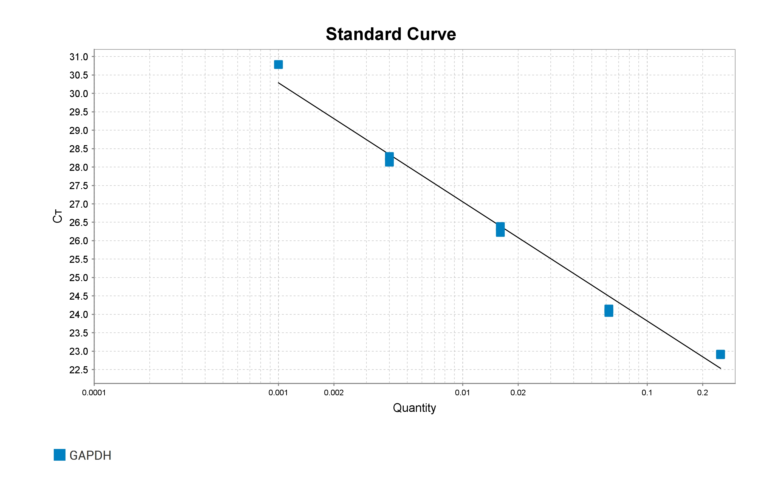

**D**

**C**

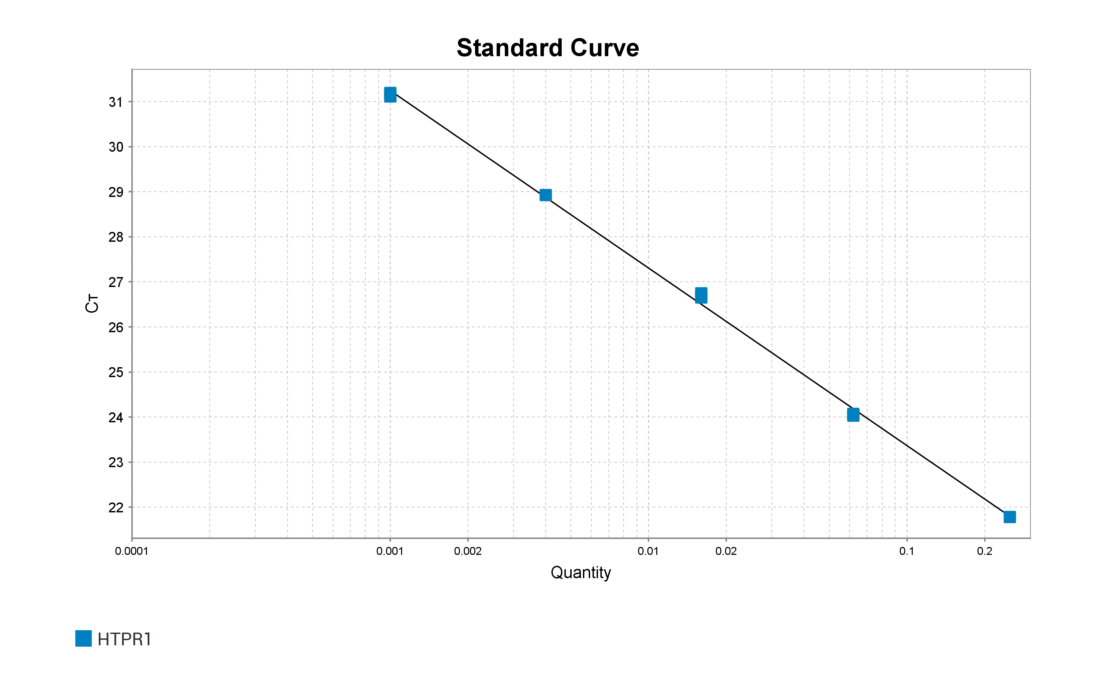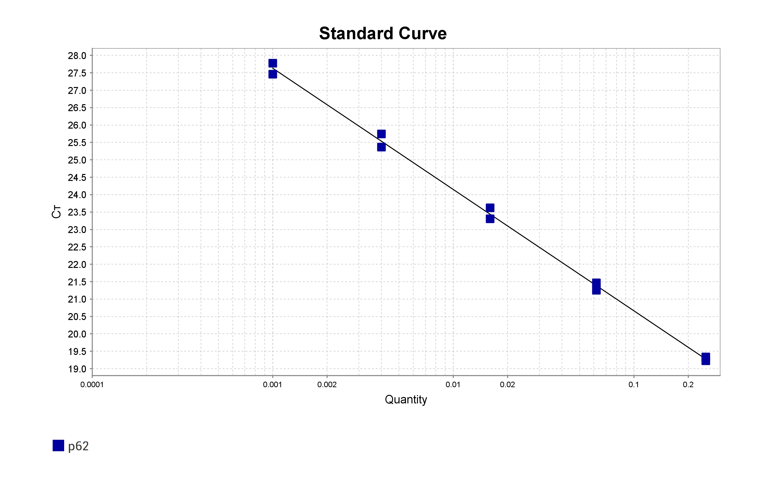

Figure S3.2. Graph taken from the GeNorm program used to find the best housekeeping for normalizing the target gene (p62) (E). GeNorm program recommended 18S and HTPR1 genes as best housekeeping; these genes showed the average stability expression below 1.5, as indicated by literature (1).

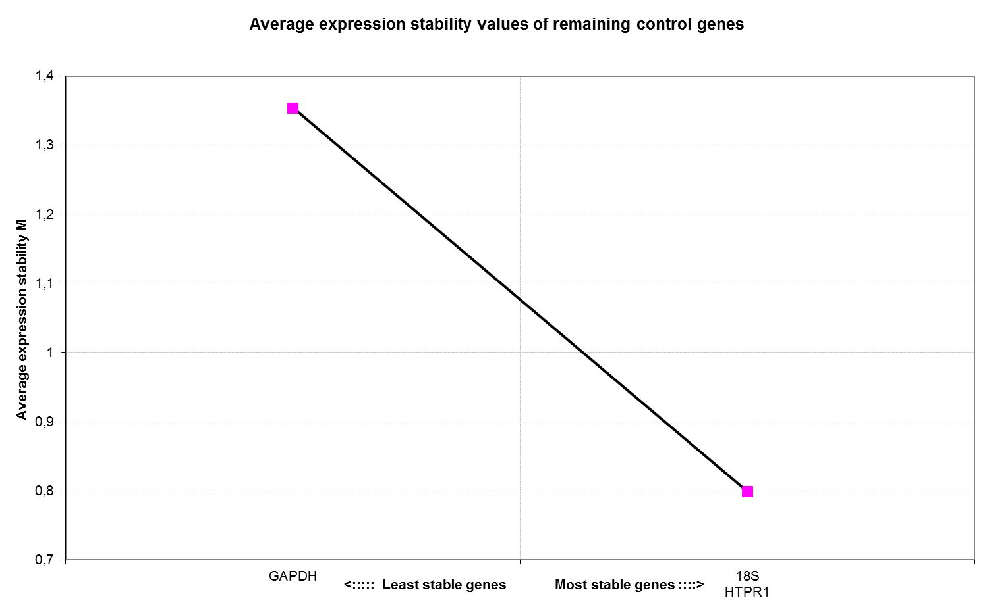

**E**

Figure S3.3 Melting and Amplification plot used to analyse of housekeeping genes (18S and HTPR1) and target gene (p62). The 18S (F and G), HTPR1 (H and I) and P62 (J and K) gene expression were determined in contralateral and hypertrophied extensor digitalis longus and soleus (EDL) muscles of control and diabetic rats. Blank (reaction with reagent without sample) and sample (reaction with reagent and sample).

**F**

**G**

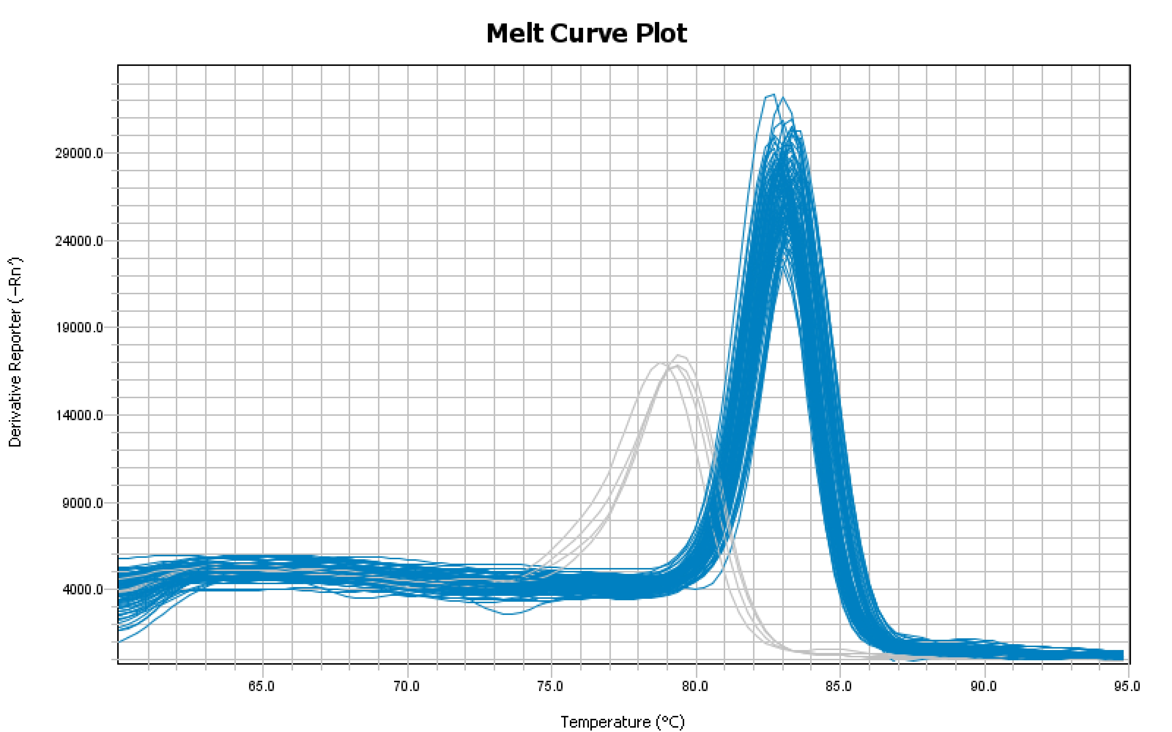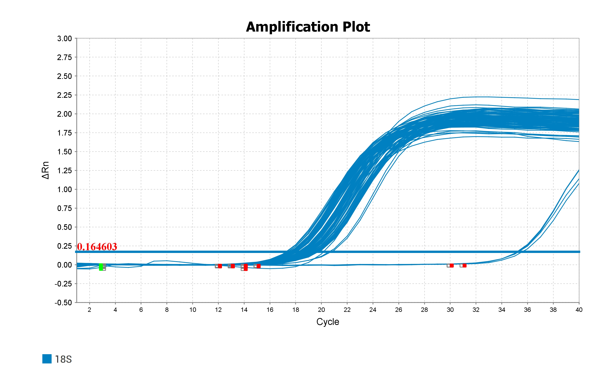

Sample

Blank

**II**

**H**

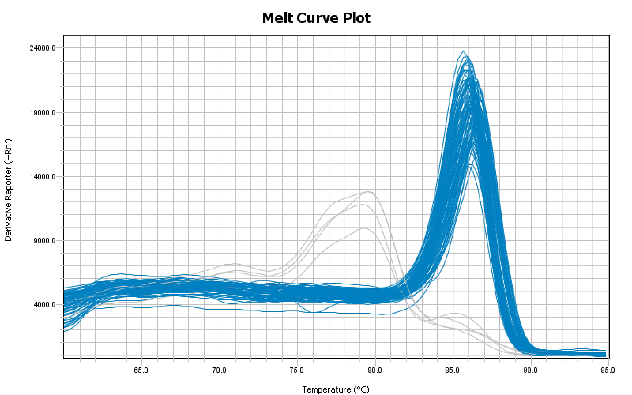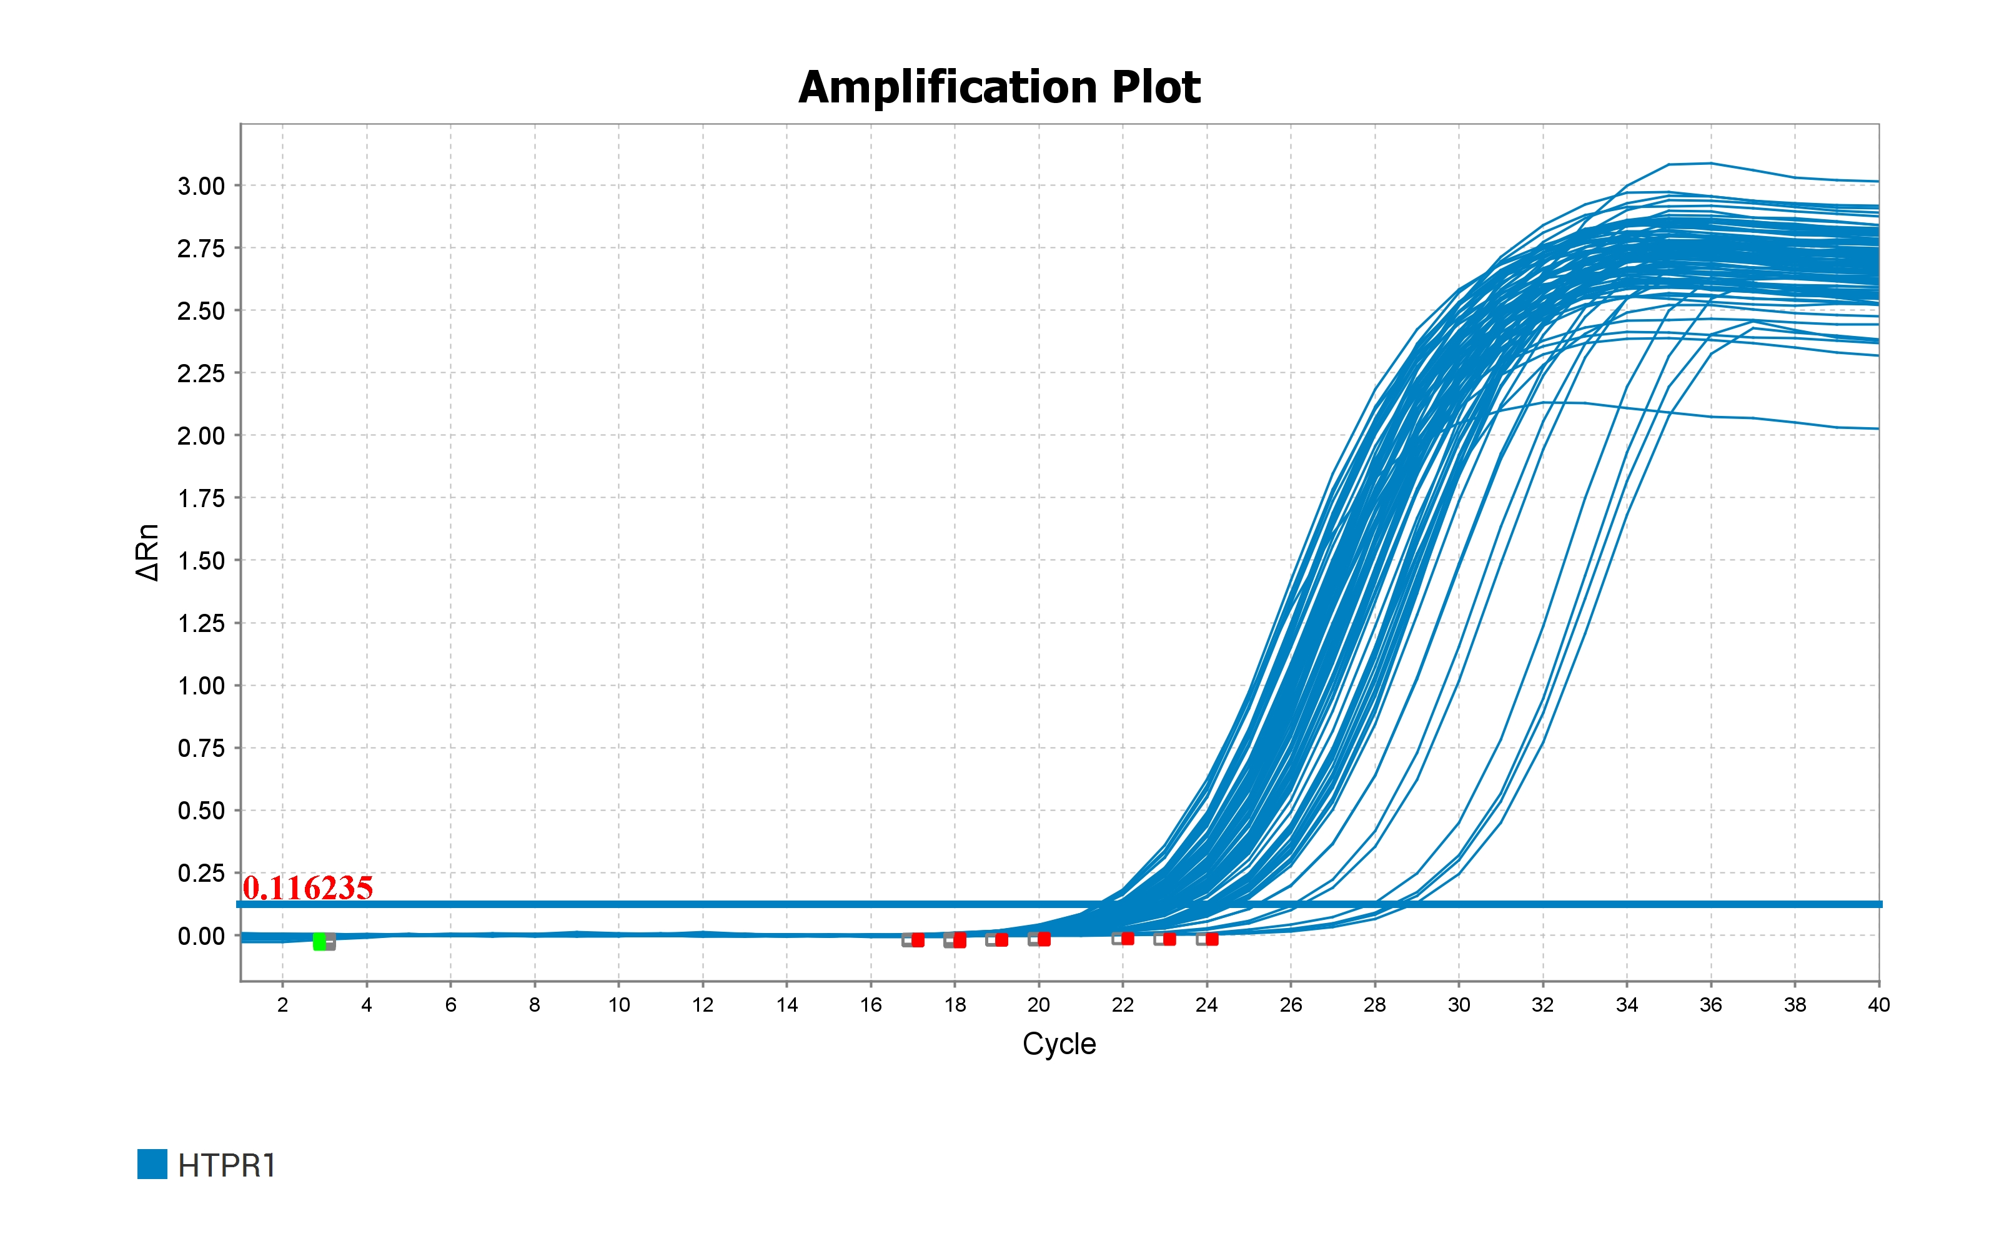

Sample

Blank

**J**

**K**

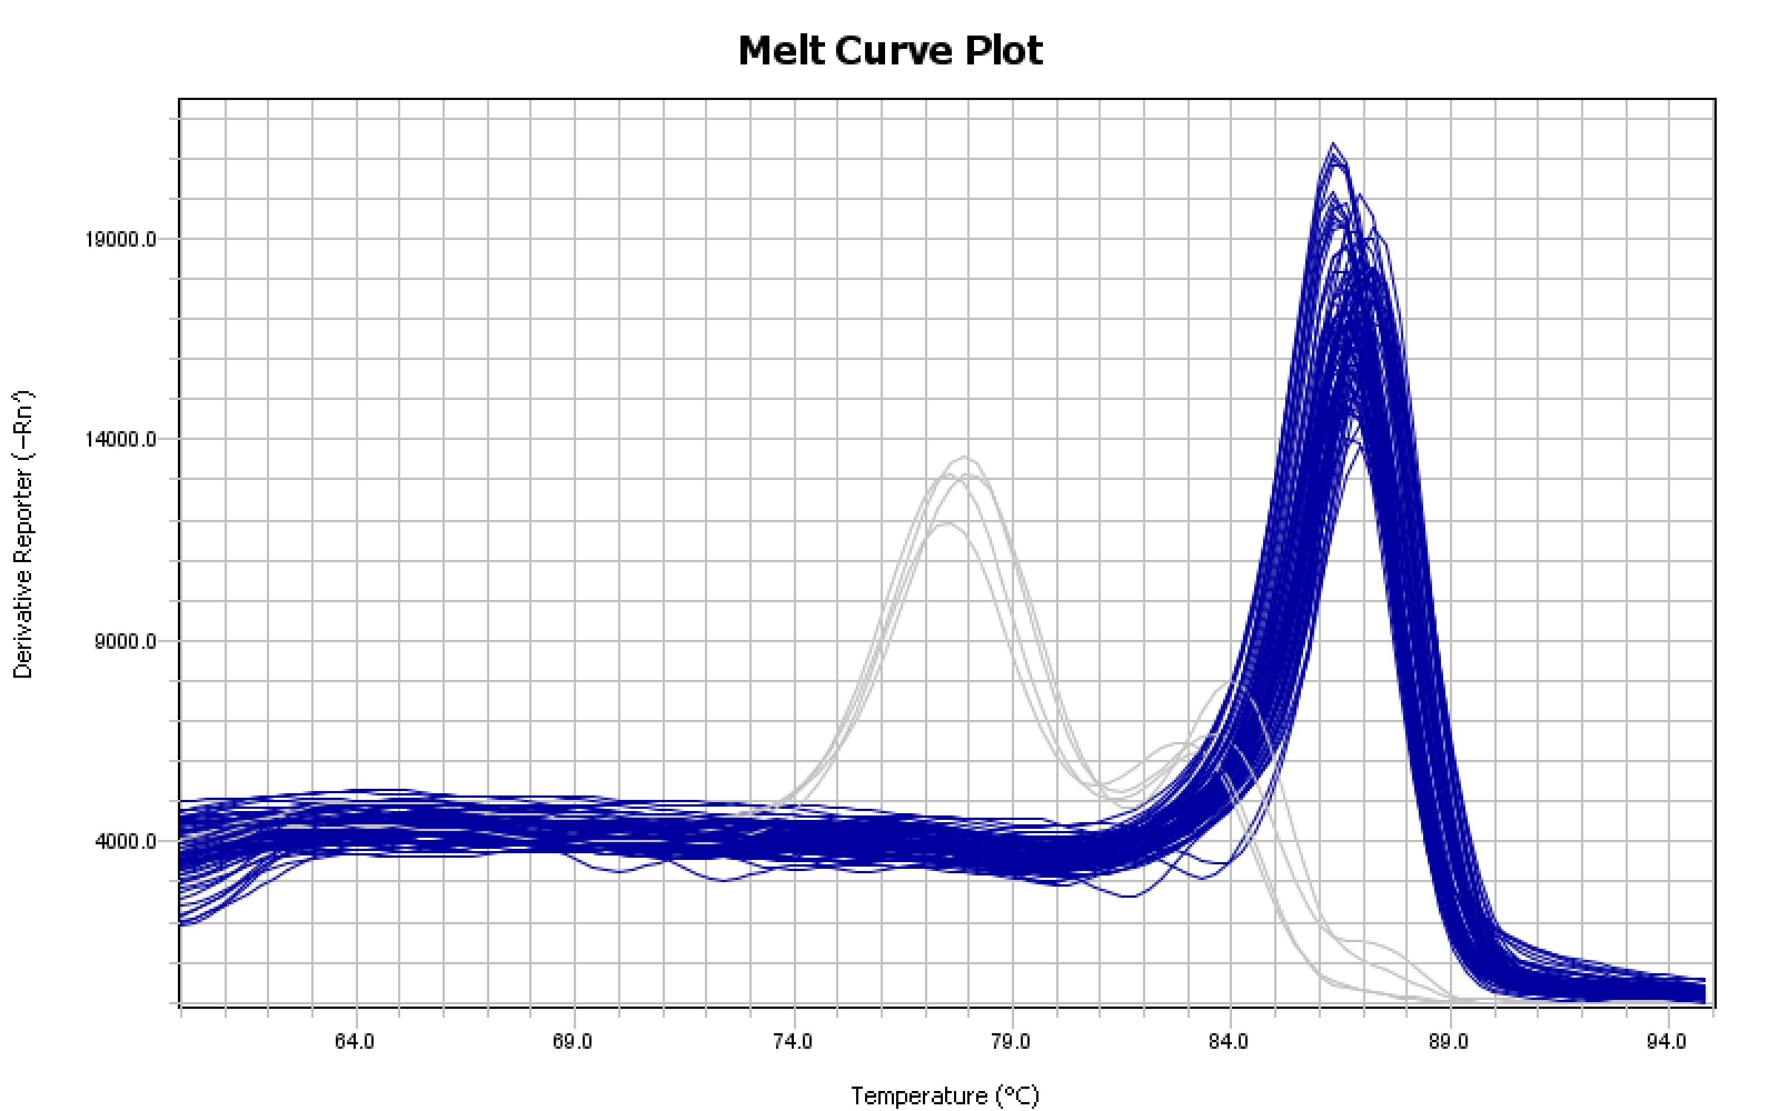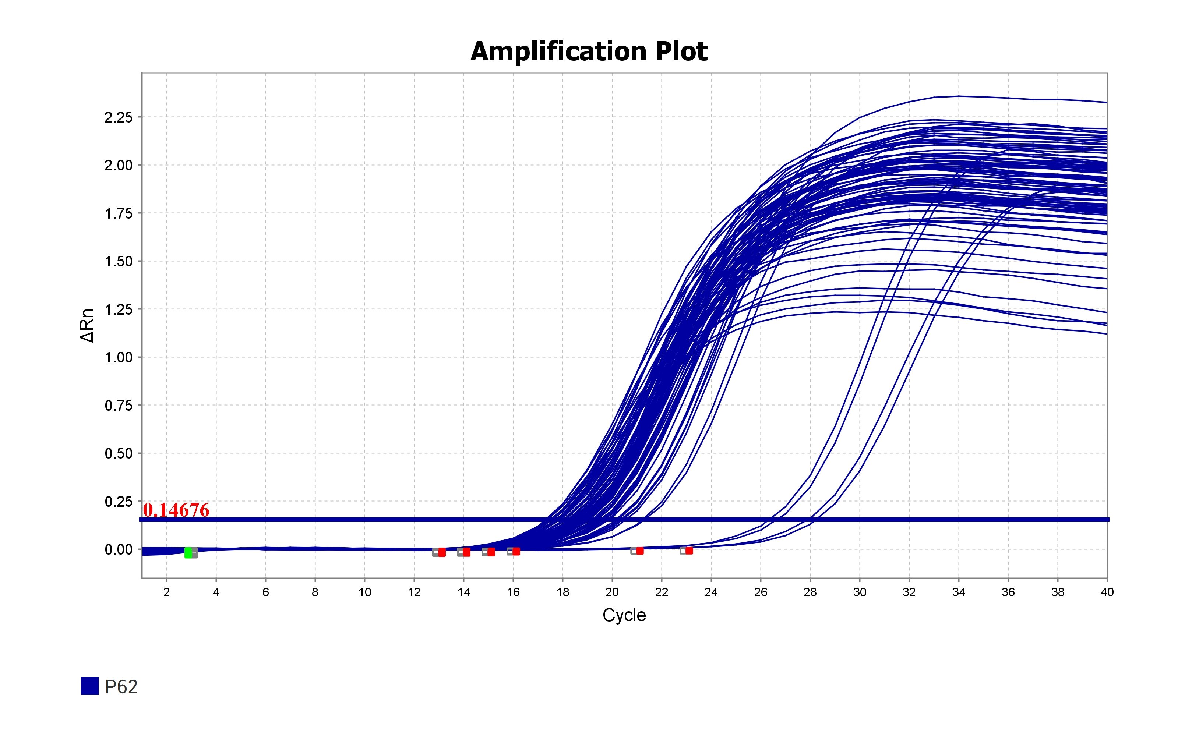

Sample

Blank

1. Vandesompele J, Preter K De, Poppe B, Roy N Van, Paepe A De. Accurate normalization of real-time quantitative RT -PCR data by geometric averaging of multiple internal control genes. Genome Biol. 2002;3:1–12.